Name: Mokgola Kholofelo
Student no: st10482863
Module Name: Web Development
Module Code: WEDE5020
Content Research and Sourcing – TechNova IT Solutions

Table Of Content
- Homepage(index.html) ………………………………………………………………. Page 3
- About us Page(index.html) …………………………………………………………. Page 4
- Service Page(index.html) ……………………………………………………………. Page 5-6
- Portfolio Page(index.html) …………………………………………………………… Page 6-7
- Contact us page (index.html) ………………………………………………………. Page 8

1. Homepage (index.html)
Purpose of this page
The homepage is the first page visitors encounter when they open the TechNova IT Solutions website. Research into professional IT websites shows that a good homepage should introduce the company, present its main services, highlight its strengths, and provide visitors with an easy way to get in touch.
The homepage will include:
- A TechNova IT Solutions logo and company name at the top of the page.
- A short welcome message explaining what the company provides.
- A brief introduction describing TechNova as an IT service provider.
- A Featured Services section listing the main IT services.
- A Why Choose Us? section highlighting the company's strengths.
- A Contact Us call-to-action allowing visitors to get in touch with the company.
How this informed index.html
- Added the TechNova IT Solutions logo to establish the company's identity.
- Added a short welcome message to immediately explain the purpose of the website.
- Added a list of the company's main IT services so visitors can quickly understand what TechNova offers.
- Added a "Why Choose Us?" section to communicate the company's strengths.
- Added a contact section and link so potential customers can easily make enquiries.
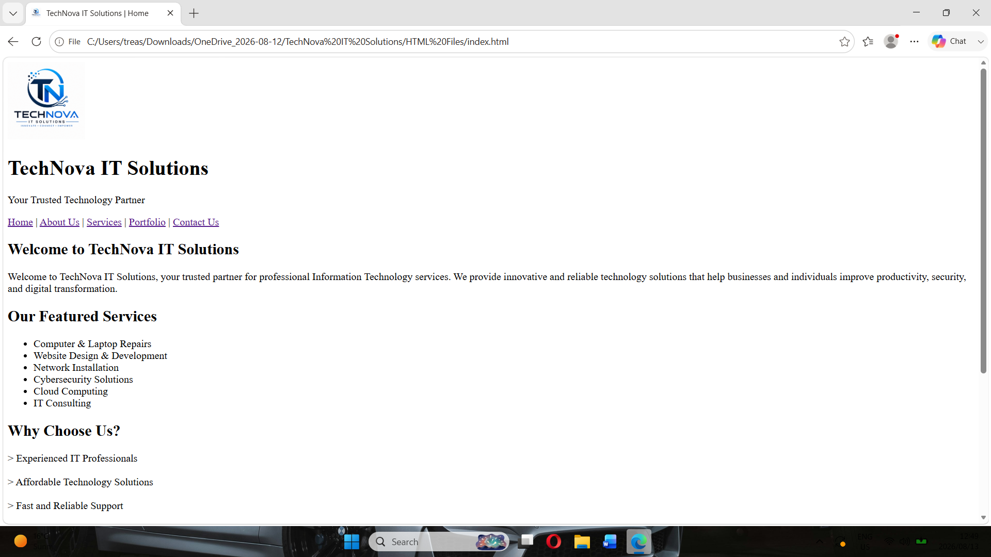

2. About Us Page (about.html)
Purpose of this page:
The About Us page gives visitors useful background information about TechNova IT Solutions. Research on business and IT websites indicates that this page can build credibility by presenting the organisation’s history, mission, vision, and overall purpose.
The page will include:
- A brief company background.
- Information about what TechNova IT Solutions does.
- The company's mission statement.
- The company's vision statement.
- Information explaining the organisation's commitment to customers.
How this informed about.html
- Added an introduction explaining the purpose of TechNova IT Solutions.
- Added the company's background to give visitors more information about the organisation.
- Added the mission statement to explain what the company aims to achieve.
- Added the vision statement to describe the company's future goals.
- Kept the information short and organised using headings and paragraphs for easy reading.
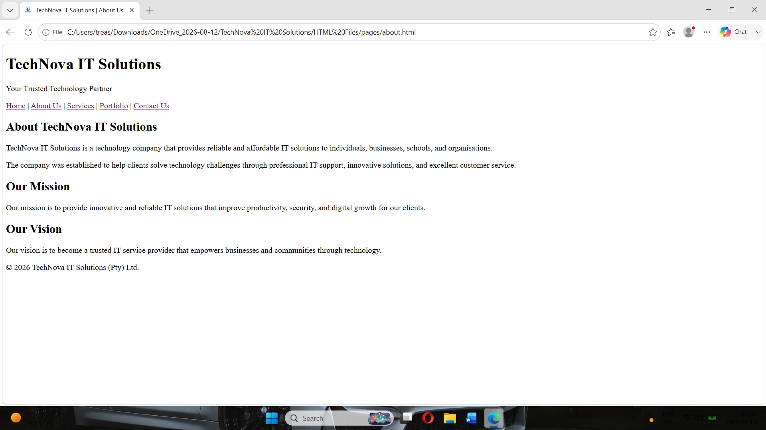

3. Services Page (services.html)
Purpose of this page
The Services page presents the various IT solutions offered by TechNova IT Solutions. Research on IT service websites shows that these pages should clearly explain the services available and include relevant images to help visitors better understand what the company provides.
The page will include:
- Computer and Laptop Repairs
- Website Design and Development
- Network Installation
- Cybersecurity Solutions
Each service will contain a short description explaining how TechNova can assist its customers.
How this informed services.html
- Created separate sections for the main IT services.
- Added relevant images to support the service descriptions.
- Used headings to make each service easy to identify.
- Added short descriptions instead of large blocks of text.
- Organised the content so visitors can quickly find the service they need.
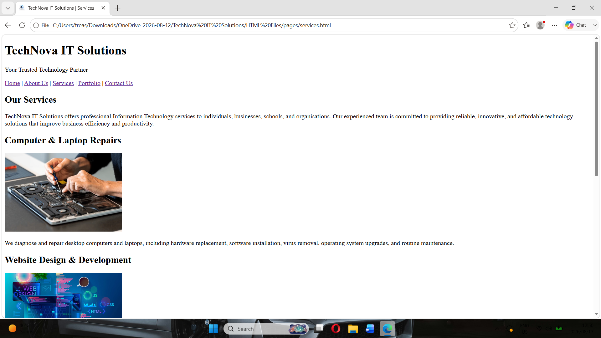

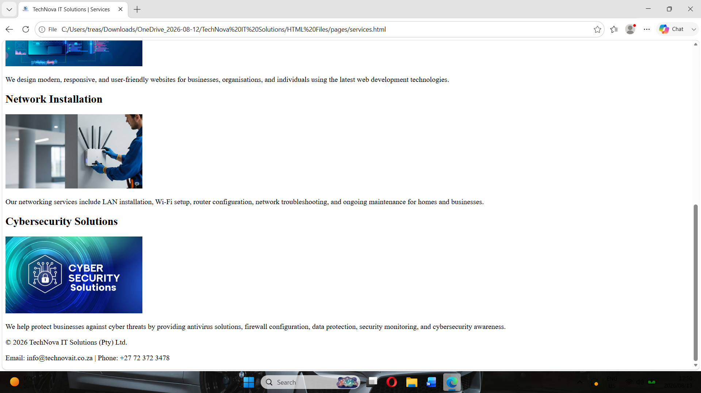

4. Portfolio Page (portfolio.html)
Purpose of this page
The Portfolio page is intended to showcase the type of work completed by TechNova IT Solutions. Research into professional technology businesses indicates that a portfolio can help potential customers understand the company’s abilities, view examples of its work, and develop greater confidence in its services.
The page will include examples of:
- Computer repair projects.
- Website development projects.
- Network installation projects.
- Cybersecurity solutions.
- Other technology-related projects.
How this informed portfolio.html
- Created sections to showcase different technology projects.
- Added images to provide visual examples of the work.
- Added short descriptions explaining each project.
- Organised the projects clearly so visitors can easily browse them.
Because TechNova IT Solutions is a fictional organisation, the projects presented on the portfolio will be realistic fictional examples created specifically for this website.
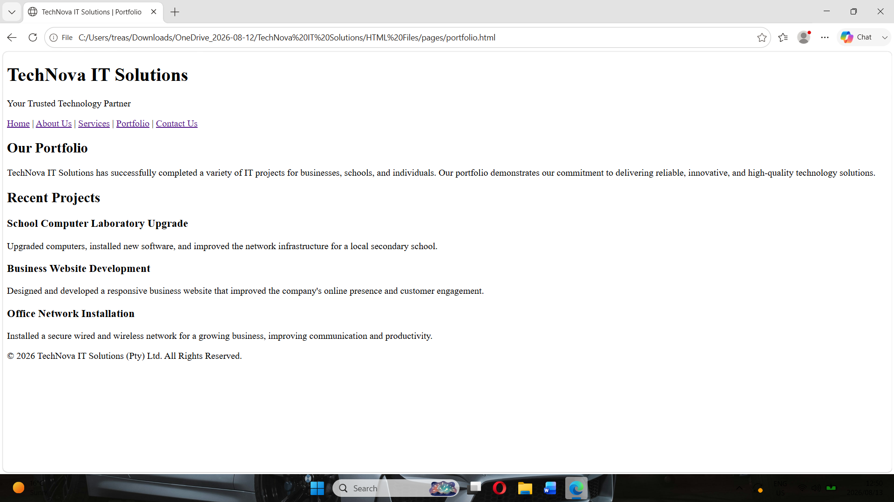

5. Contact Us Page (contact.html)
Purpose of this page
The Contact Us page provides customers with an easy way to communicate with TechNova IT Solutions. Research into professional business websites shows that contact pages commonly provide telephone numbers, email addresses, physical addresses, operating hours, and enquiry forms.
The page will include:
- Company telephone number.
- Company email address.
- Physical address.
- Business hours.
- Customer enquiry form.
- Navigation links to the other website pages.
How this informed contact.html
- Added the company's contact information in a clear format.
- Created an enquiry form containing fields for the customer's name, email address, subject, and message.
- Added a "Send Message" button.
- Included the navigation menu so visitors can easily move to other pages.
- Added the company copyright information in the footer.
